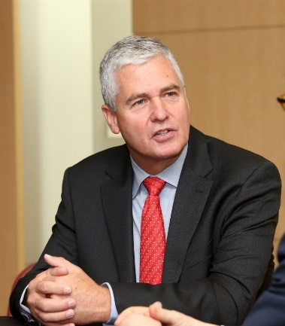
Dr. Frank Rijsberman
Director-General
Global Green Growth Institute (GGGI)
Dr. Frank Rijsberman leads the Global Green Growth Institute (GGGI) in supporting governments transition toward a model of economic growth that is environmentally sustainable and socially inclusive. With over 30 years’ experience addressing the challenges of environmental sustainability and poverty reduction with leading international organizations and philanthropic foundations, Dr. Rijsberman was appointed as the Director-General of the Institute, on October 1, 2016.
Upon assuming his position, Dr. Rijsberman has engaged with senior international stakeholders to drive the green growth agenda and help mobilize finance for climate action and sustainable development. As an advocate for sustainable development, Dr. Rijsberman is focused on supporting GGGI Member and partner governments to implement their Nationally Determined Contributions (NDCs) under the Paris Agreement and achieve their Sustainable Development Goal (SDG) targets. His priorities are to support collaborative NDC implementation among GGGI Members, as outlined under Article 6 of the Paris Agreement and assist its Member governments to green their investment to deliver inclusive, pro-poor green growth, as well as climate action.
Prior to joining GGGI, Dr. Rijsberman served as Chief Executive Officer of the Consultative Group for International Agricultural Research (CGIAR) Consortium. In this role, he led CGIAR’s transformation from 15 independent research centers towards a single integrated organization. This included a process of cultural and institutional change towards results-based management, including the development of the Consortium’s 2016-2030 Strategy and new portfolio of research programs for 2017-2022, building an integrated organization and governance structure, and developing its policies and procedures to ensure accountability.
From 2010 to 2012, Dr. Rijsberman was the first Director of Water, Sanitation, and Hygiene for the Bill and Melinda Gates Foundation, where he developed a strategy to help achieve universal access to sustainable sanitation services using radical new technologies and innovative market-based mechanisms.
Dr. Rijsberman also has worked as Program Director at Google.org, the philanthropic arm of Google, where he led grant making in the public health initiative and was responsible for programs and partnerships in health, disaster response, geo-informatics, and climate-change adaptation.
Before working at Google, Dr. Rijsberman was Director-General of the International Water Management Institute, an international research institute with HQ in Colombo, Sri Lanka. He holds a PhD degree in water resources management and planning from Colorado State University (US) and a MSc and BS in Civil Engineering from Delft University of Technology (Netherlands).
Twitter: @FrankRijsberman

